Name : Zuha Irfan
Roll No : 2023-BSE-073
Subject: Cloud Computing
Semester & Section : V-B
Lab : 09

Task 1 — GitHub CLI, Codespace setup and authentication
- task1_gh_install.png
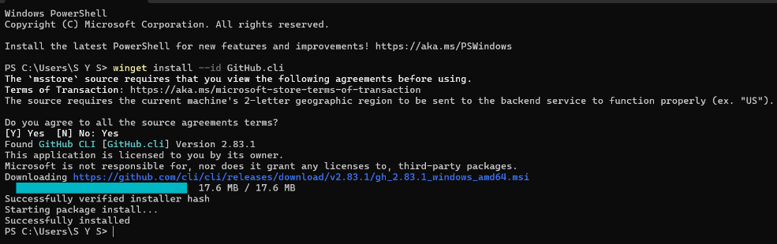
- task1_gh_auth_login.png
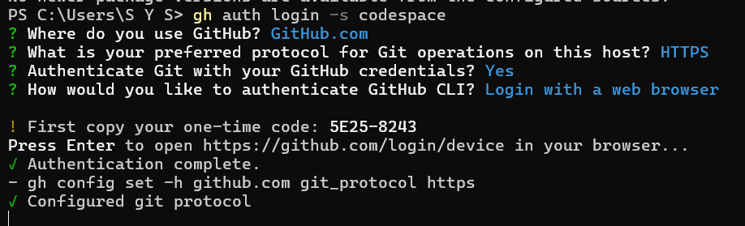

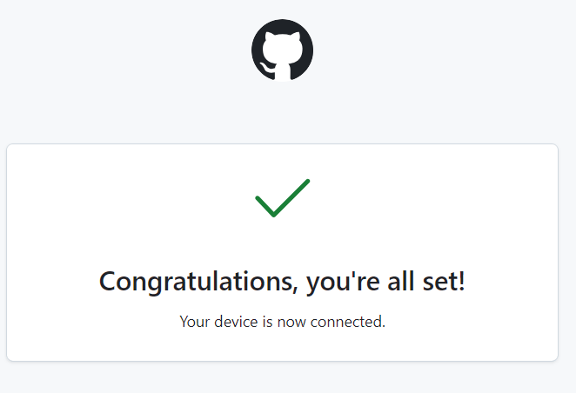
- task1_codespace_list.png
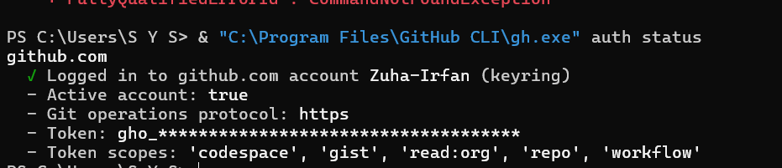
- task1_codespace_ssh_connected.png
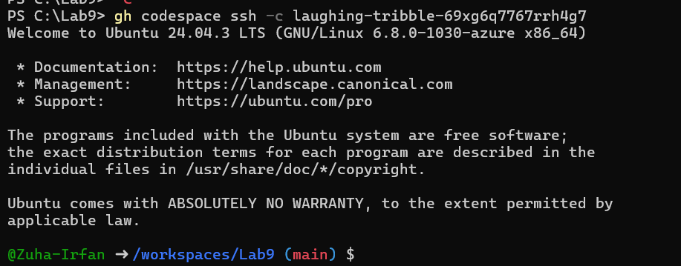

Task 2 — Install AWS CLI inside the Codespace and configure it
- task2_aws_install_and_version.png
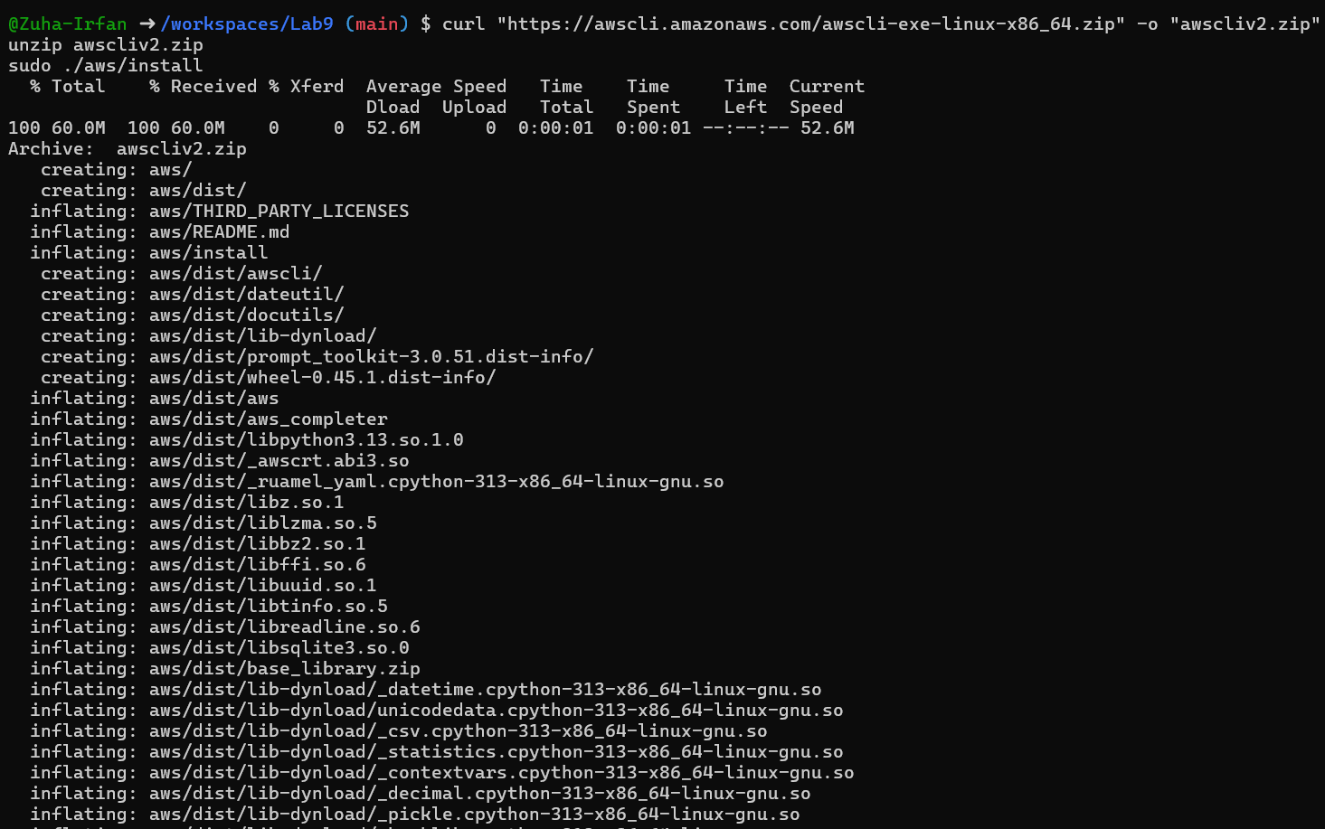
- task2_aws_configure_and_files.png
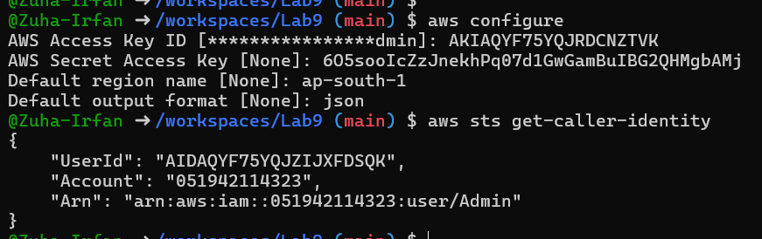

- task2_aws_get_caller_identity.png

Task 3 — Create security group and add ingress rules using Codespace IP
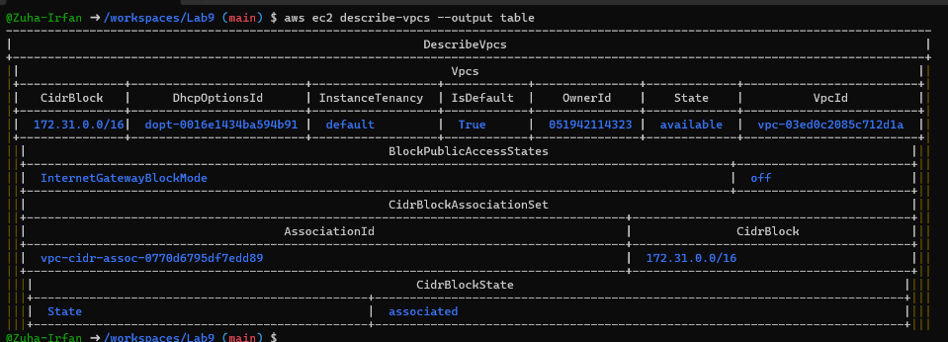
- task3_create_security_group_output.png

- task3_describe_sg_before_ingress.png
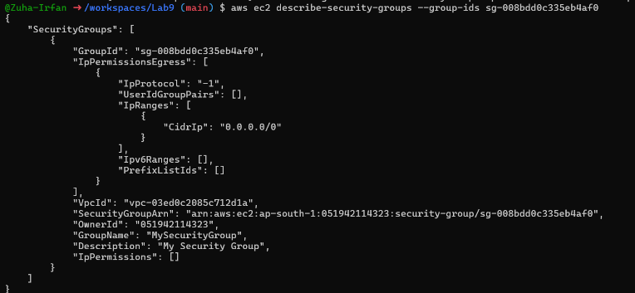

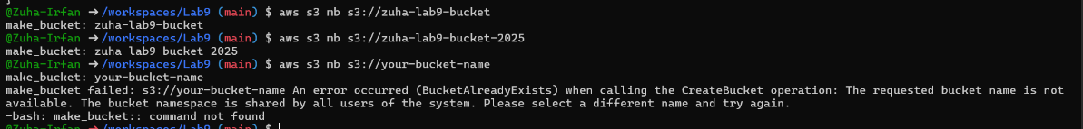

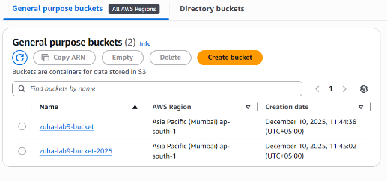

- task3_codespace_public_ip.png
- task3_authorize_ssh_and_describe.png
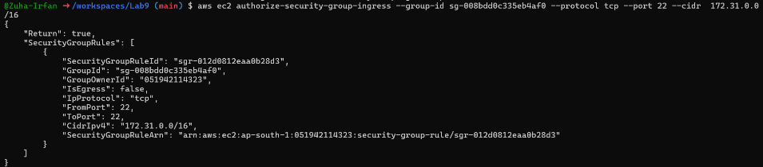

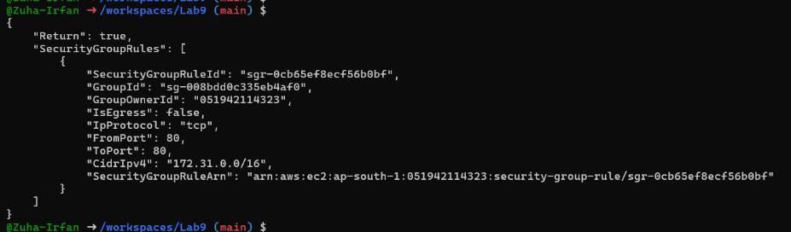
- task3_authorize_http_and_describe.png

- task3_describe_sg_final.png
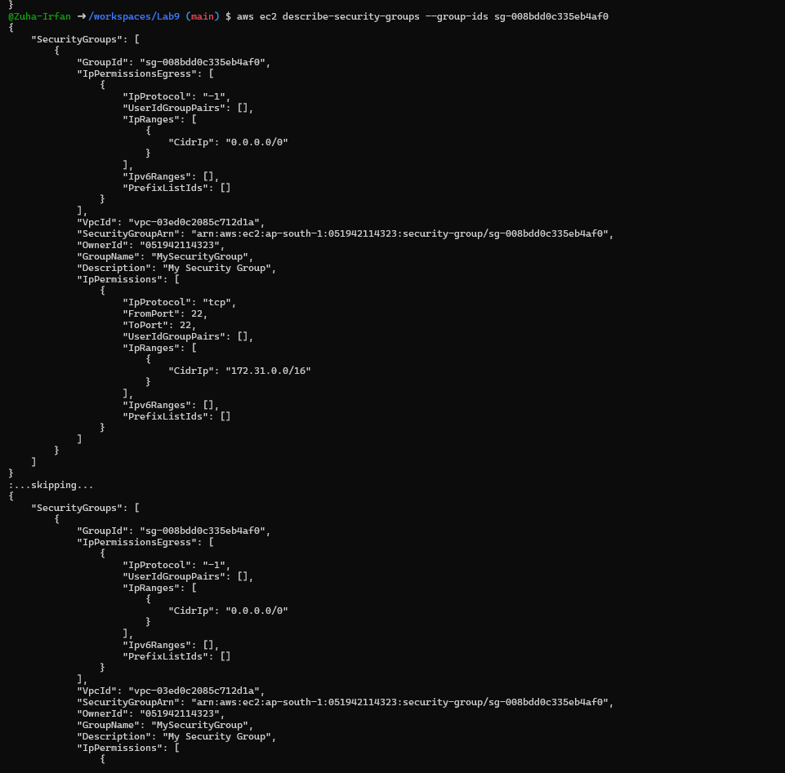

Task 4 — Create a key pair, describe key pairs, and launch EC2 instanc
- task4_create_keypair_output.png
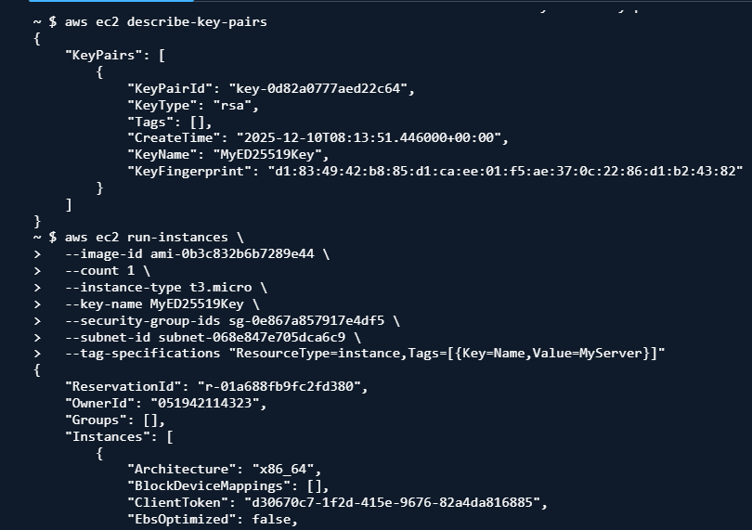
- task4_describe_keypairs.png

- task4_delete_keypair_optional.png
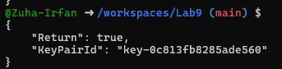

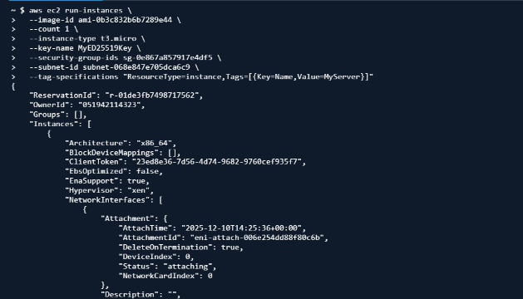
- task4_run_instances_output.png

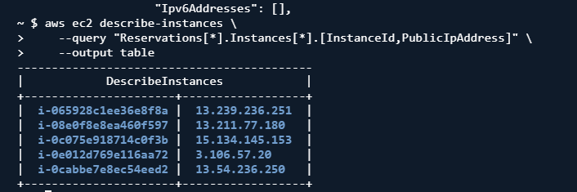
- task4_describe_instances_public_ip.png

- task4_ssh_permission_error_and_fix.png
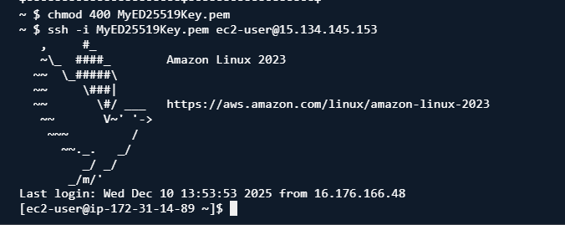
- task4_stop_start_terminate_commands.png
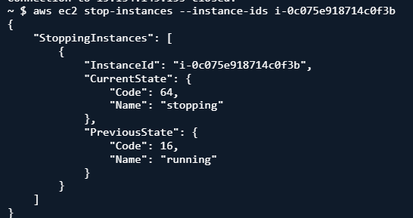

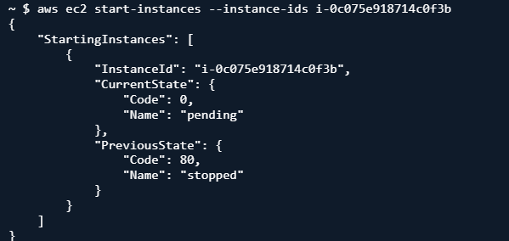

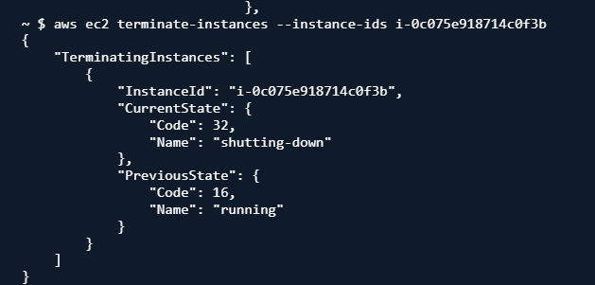

Task 5 — Understand AWS describe-* commands
- task5_describe_security_groups.png
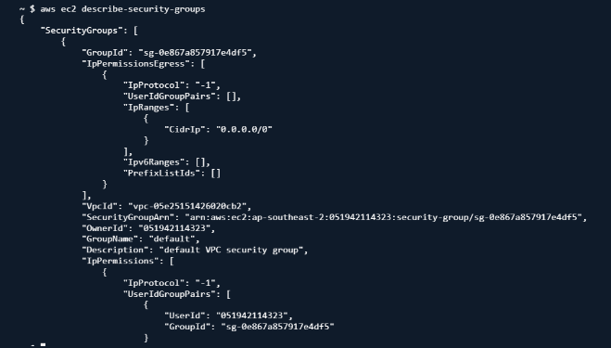

- task5_describe_vpcs.png
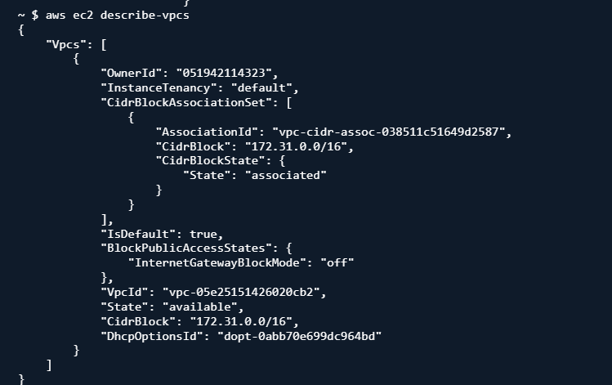

- task5_describe_subnets.png
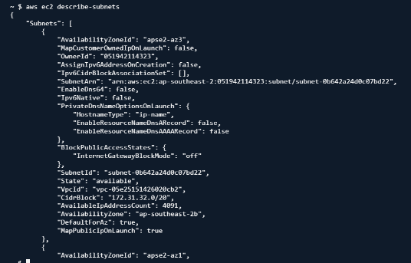

- task5_describe_instances.png
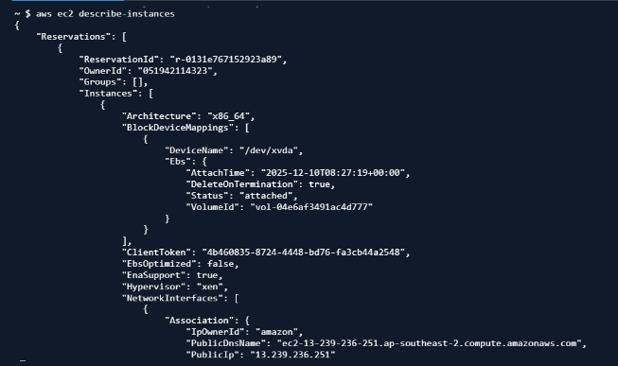

- task5_describe_regions.png
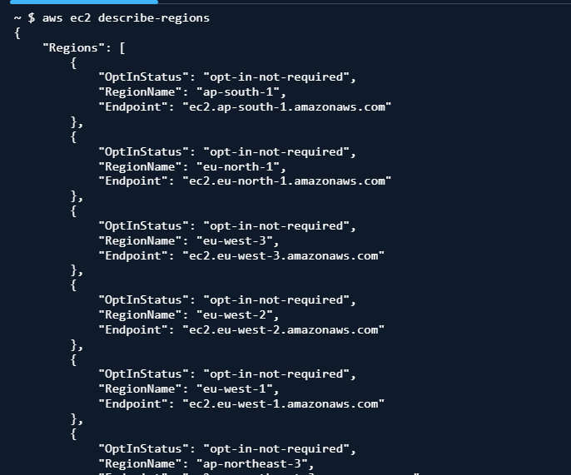

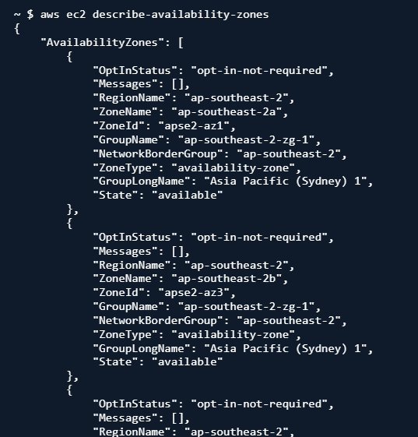
- task5_describe_availability_zones.png

Task 6 — IAM: create group, user, attach policies, create console login & keys
- task6_create_group_and_user.png
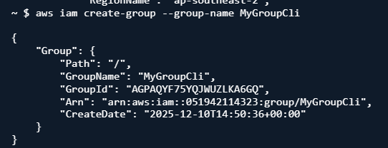

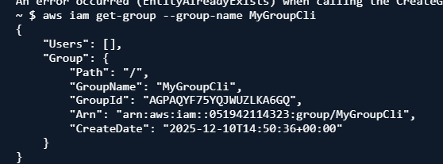

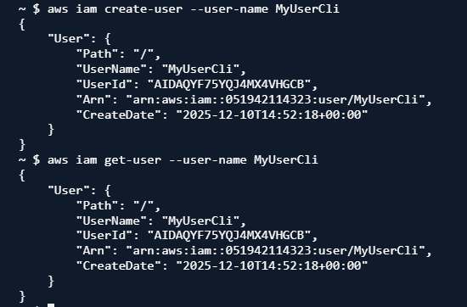

- task6_add_user_to_group_and_verify.png
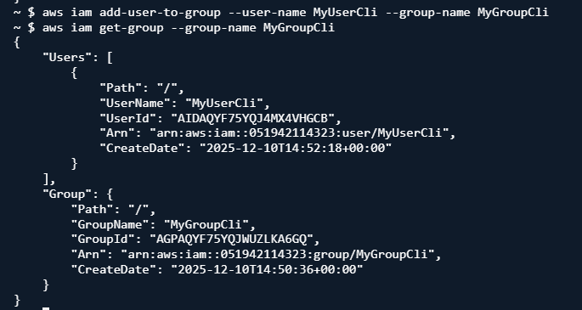

- task6_policy_list_and_attach.png
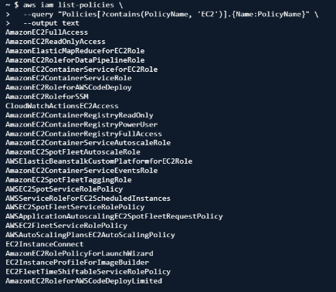

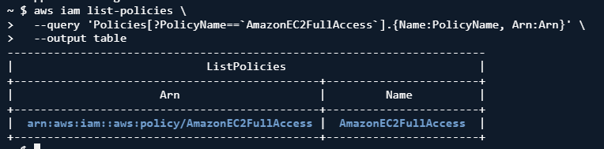

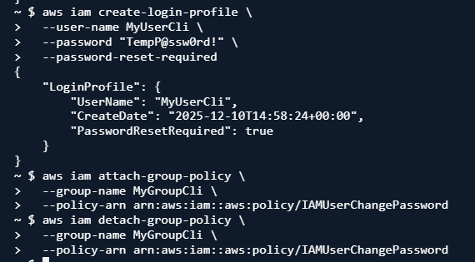
- task6_create_login_profile_and_signin.png
- task6_create_access_key_output.png
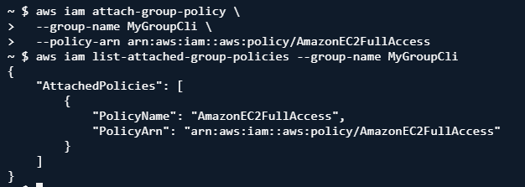
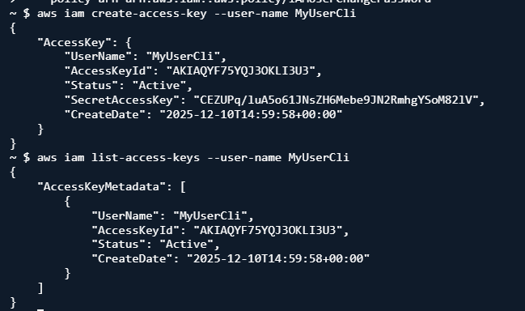

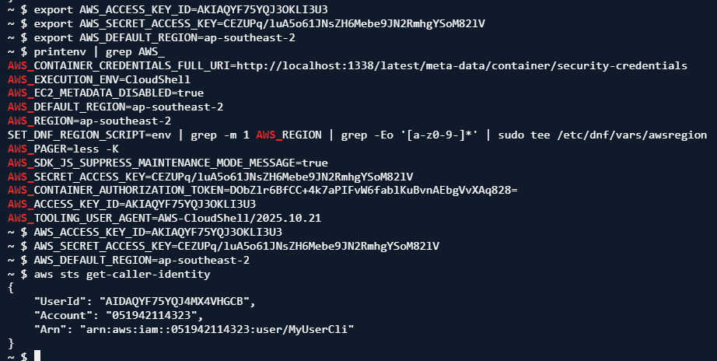
- task6_env_exports_and_get_user_error.png

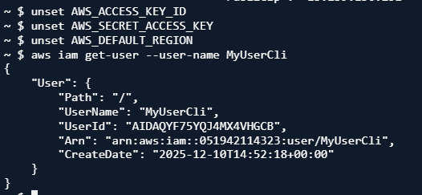
- task6_after_logout_and_get_user_success.png

Task 7 — Filters: query with filters to find instances and their attributes
- task7_filter_by_tag_public_ip.png
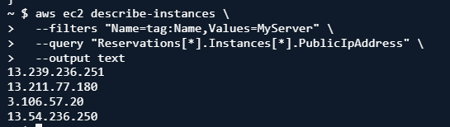

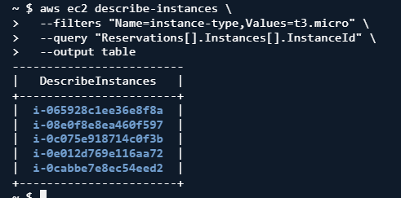
- task7_filter_by_instance_type.png

- task7_filter_by_subnet.png
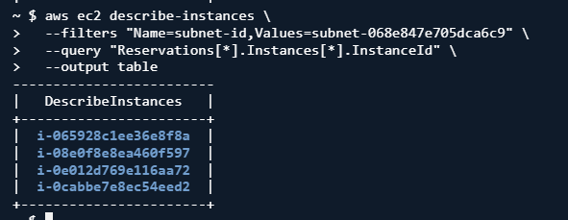

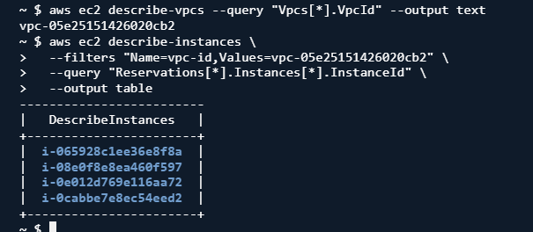
- task7_filter_by_vpc.png

Task 8 — Use --query to format outputs for reporting
- task8_query_table_instances_name_ip.png
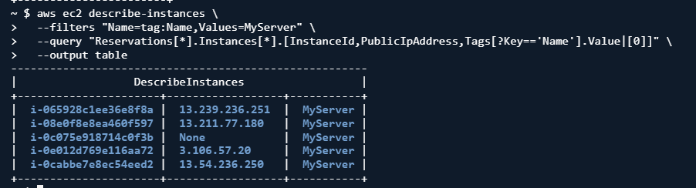

- task8_query_table_instance_state.png

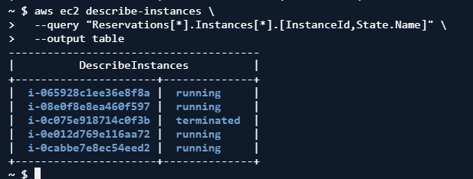

- task8_query_table_instance_type_az.png
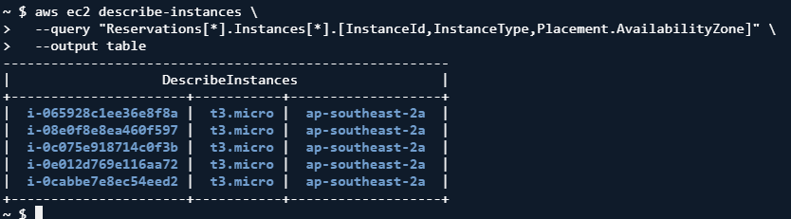

Cleanup — Remove resources to avoid charges
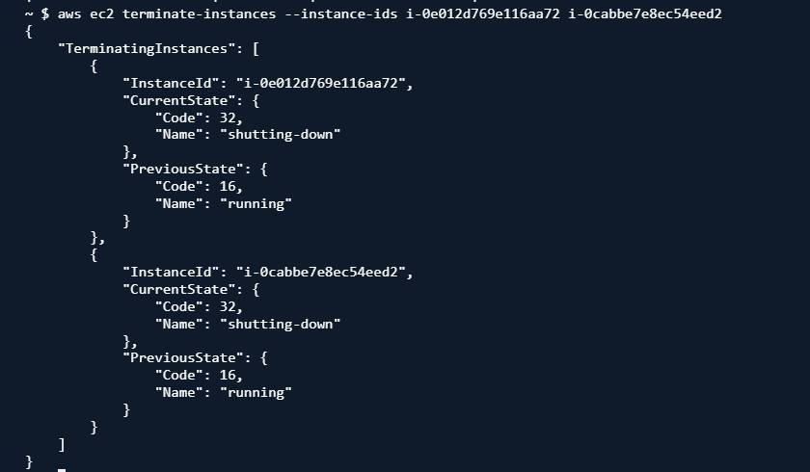
- cleanup_terminate_instance.png

- cleanup_delete_volumes_snapshots.png
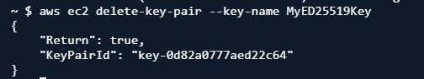
- cleanup_delete_security_group_and_keypair.png

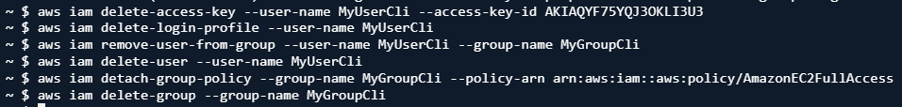
- cleanup_iam_users_deleted.png

- cleanup_summary.png
